**Sinclair, May (1863-1946)**

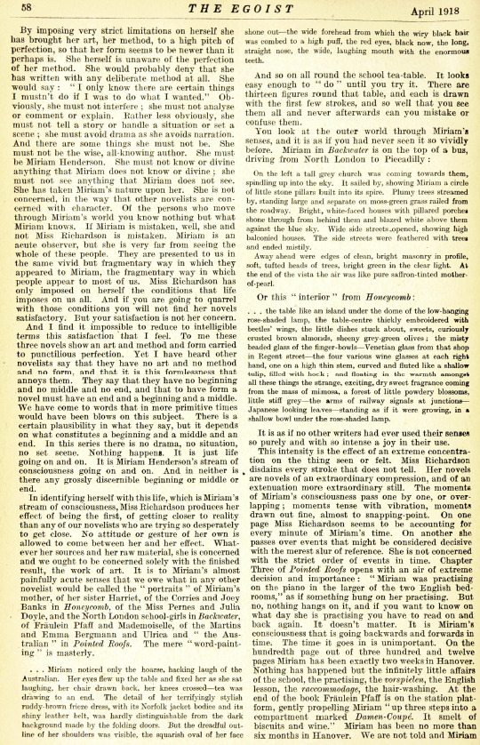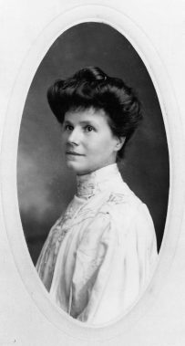May Sinclair was a novelist, journalist and literary critic. She began writing relatively late in life to help support her family, and while most of her novels would most obviously be categorised as realist, she was a great advocate for the experimentation of writers such as Virginia Woolf and Dorothy Richardson, and is perhaps most influential today as a literary critic of modernism; she was for example the first critic to use the term ‘stream of consciousness’ in relation to literature. Her first commercial success came with her third novel *The Divine Fire* (1904), a philosophical novel combining a love story with an exploration and critique of the contemporary literary marketplace. Subsequent novels focused largely on social and/or marriage problems, prominent themes in literature of the period. A committed campaigner for women’s rights, her World War One novels (*Tasker Jevons: the Real Story* of 1916 and *The Tree of Heaven* of 1917) express her support for the war at a time when the suffrage movement was split between pacifist and pro-combat factions. She wrote two identifiably experimental novels, *Mary Olivier* (1919) and *The Life and Death of Harriett Frean* (1922), both significantly influenced by her interest in psychoanalysis.

The first literary critical use of the term ‘stream of consciousness’, in Sinclair’s influential review of Dorothy Richardson’s fiction.

url: <http://dl.lib.brown.edu/pdfs/1308747877743754.pdf>

This item might be better as a pop-out so that it can be large enough for the type to be legible. Alternatively you could cut out the relevant section of the page, which are the last 4 lines of the second paragraph, first column.

A photograph of May Sinclair taken around 1898.

url: <http://nationalhumanitiescenter.org/ideasv62/raittb.htm>

**Selected list of works**

*Audrey Craven* (1897)

*The Divine Fire* (1904)

*The Helpmate* (1907)

*The Judgment of Eve* (1907)

*The Immortal Moment* (1908)

*The Creators* (1910)

*The Flaw in the Crystal* (1912)

*The Three Brontës* (1912)

*Feminism* (1912)

*The Three Sisters* (1914)

*The Return of the Prodigal* (1914)

*A Journal of Impressions in Belgium* (1915)

*The Belfry* (1916)

*Tasker Jevons: The Real Story* (1916)

*The Tree of Heaven* (1917)

*A Defense of Idealism : Some Questions & Conclusions* (1917)

*Mary Olivier: A Life* (1919)

*Life and Death of Harriett Frean* (1922)

*The New Idealism* (1922)

*Uncanny Stories* (1923)

*Arnold Waterlow* (1924)

*The Rector of Wyck* (1925)

*The Allinghams* (1927)

*Tales Told by Simpson* (1930) stories

*The Intercessor, and Other Stories* (1931)

**Further reading**

Boll, Theophilus E. M. (1973) *Miss May Sinclair: Novelist; A Biographical and Critical Introduction*, Cranberry, NJ: Associated University Presses.

Kunka, Andrew J. and Michele K. Troy (eds) (2006) [*May Sinclair: moving towards the modern*](http://encore.lib.gla.ac.uk/iii/encore/record/C__Rb2470388__Smay%20sinclair__Orightresult__X5?lang=eng&suite=cobalt), Aldershot: Ashgate.

Raitt, Suzanne (2000) *May Sinclair: A Modern Victorian*, Oxford: Clarendon Press.

Zegger, Hrissey D. (1976) *May Sinclair,* Boston: Twayne.

Bryony Randall, University of Glasgow